Particular | Details
Department: | B.Tech
Programme: | Information Technology
Course Code & Course Name | CSA0904-Programming in Java
Academic Year / Batch | 2024
Faculty Name | Dr.R.Thalapthi Rajasekaran
Assignment Title | Smart Library Management System
Date of Issue | 01-09-2026
Date of Submission | 02-09-2026
Maximum Marks

1. Problem Statement and Problem Formulation
A library requires an efficient system to manage books, members, borrowing, reservations, overdue notifications, and report generation. Manual record maintenance is time-consuming and prone to errors such as duplicate entries, inaccurate inventory, and delayed notifications.
The proposed Smart Library Management System is a Java Applet-based GUI application that automates these activities using Object-Oriented Programming, Java Collections Framework, Exception Handling, and Multithreading. The system maintains book availability, supports reservations through a waiting list, generates reports, and sends due-date and overdue notifications while ensuring safe concurrent access to shared library resources.
2. Objective and Expected Outcomes
Objectives
- Develop a Java Applet-based GUI application.
- Apply Object-Oriented Programming concepts.
- Manage books and members efficiently.
- Automate book issue and return.
- Implement reservation and notification features.
- Generate circulation and inventory reports.
- Demonstrate multithreading and synchronization.
Expected Outcomes
- Accurate book inventory.
- Fast member registration.
- Automated fine calculation.
- Efficient reservation management.
- Reliable overdue notification.
- Reduced manual errors.

3. Requirements, Constraints and Assumptions
Functional Requirements
- Add books
- Register members
- Search books
- Issue books
- Return books
- Reserve books
- Cancel reservations
- Display books
- Display members
- Generate reports
- Send notifications
Constraints
- Java Applet GUI Application
- JDK 17
- CSV files used as persistent database
- Single administrator
Assumptions
- Book ID is unique.
- Member ID is unique.
- Fine is calculated only for overdue books.
- Notifications are displayed through the graphical user interface.

4. Application of Relevant Course Knowledge
The project demonstrates the following Java concepts:
- Classes and Objects
- Encapsulation
- Data Hiding
- Constructors
- Inheritance
- Polymorphism
- Method Overriding
- ArrayList
- HashMap
- HashSet
- Iterator
- Exception Handling
- User-defined Exceptions
- Multithreading
- Synchronization
- Generics
5. Design / Proposed Solution / Methodology
The system is divided into the following modules:
Book Management
- Add Book
- Search Book
- Display Books
Member Management
- Register Member
- Display Members
Transaction Module
- Issue Book
- Return Book
Reservation Module
- Reserve Book
- Cancel Reservation
Notification Module
- Due Notifications
- Overdue Notifications
Report Module
- Inventory Report
- Borrow Report
- Fine Report

6. Algorithm / Pseudocode
START
Display Main Menu
Repeat
Read User Choice
IF Choice = 1
Add Book
ELSE IF Choice = 2
Register Member
ELSE IF Choice = 3
Search Book
ELSE IF Choice = 4
Issue Book
ELSE IF Choice = 5
Return Book
ELSE IF Choice = 6
Reserve Book
ELSE IF Choice = 7
Cancel Reservation
ELSE IF Choice = 8
Display Books
ELSE IF Choice = 9
Display Members
ELSE IF Choice = 10
Generate Reports
ELSE IF Choice = 11
Send Notifications
ELSE IF Choice = 12
Exit
UNTIL Exit
STOP

7. Implementation / Environment / Tools Used
Software Used
Tool | Purpose
Java JDK 17 | Programming Language and Runtime
IntelliJ IDEA | Code Development and Debugging
Antigravity AI | AI-assisted code generation and development support
Windows 11 | Operating System

Development Environment
- Programming Language: Java
- JDK Version: 17
- IDE: IntelliJ IDEA
- Operating System: Windows 11
- Application Type: GUI-based Java Applet Application
8. Test Cases
Test Case | Expected Result | Actual Result | Status
Add Book | Book Added | Book Added | Pass
Register Member | Member Registered | Member Registered | Pass
Search Book | Book Found | Book Found | Pass
Issue Book | Book Issued | Book Issued | Pass
Return Book | Book Returned | Book Returned | Pass
Reserve Book | Reservation Created | Reservation Created | Pass
Generate Report | Report Displayed | Report Displayed | Pass
Notification | Message Displayed | Message Displayed | Pass
9. Execution Screenshots / Outputs
Figure 1: Main Menu
The Smart Library Management System starts by loading sample books, members, active loans, and reservation data. A menu is displayed with twelve options, allowing users to perform operations such as adding books, registering members, issuing and returning books, reserving books, generating reports, sending notifications, and exiting the application.
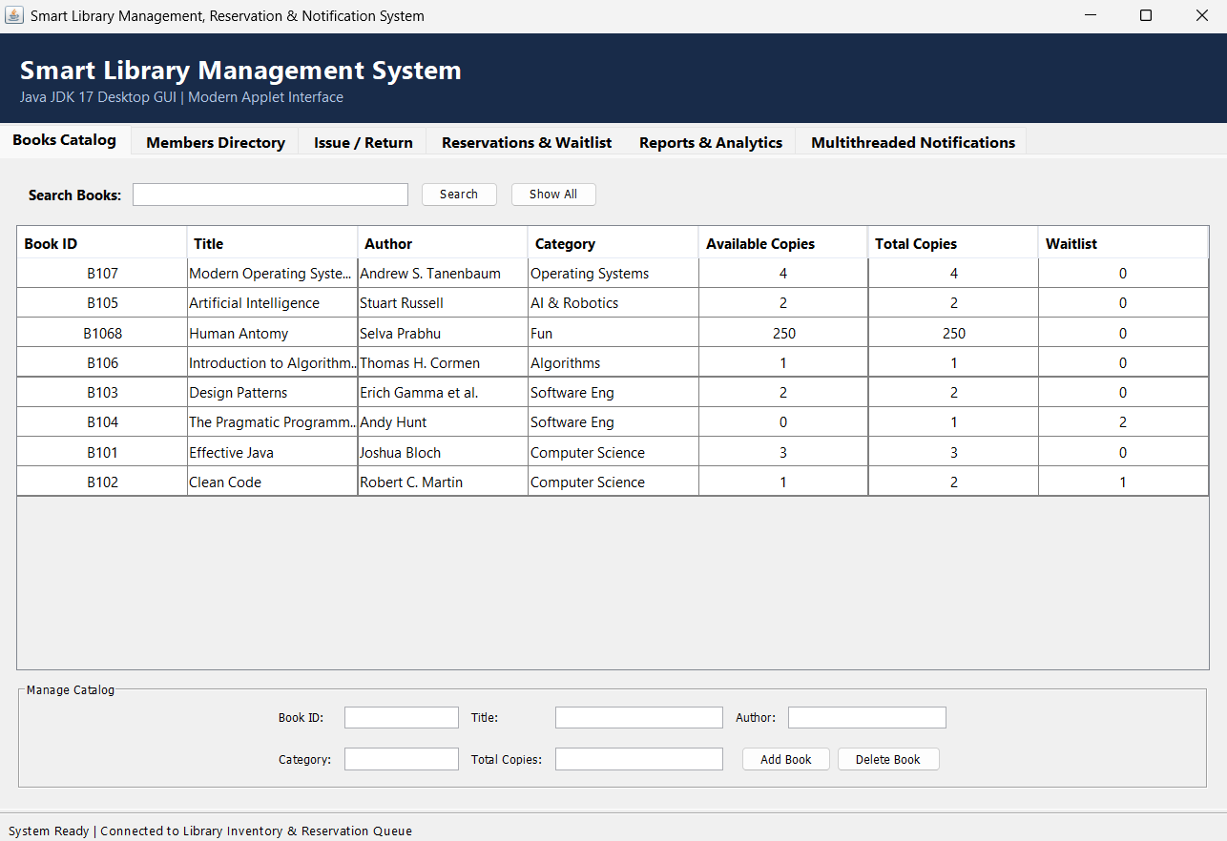
Figure 2: Add Book
The Add Book module allows the administrator to enter the details of a new book, including Book ID, title, author, category, and the number of available copies. After successful validation, the book is added to the library inventory, and a confirmation message is displayed.

Figure 3: Register Member
The Register Member module enables the administrator to add a new library member by entering the member ID, name, contact details, and membership type. Once the information is validated, the member is successfully registered in the system.
Figure 4: Search Book
The Search Book module allows users to search for a book using its Book ID or title. If the requested book exists, the application displays complete information including the title, author, category, and availability status.
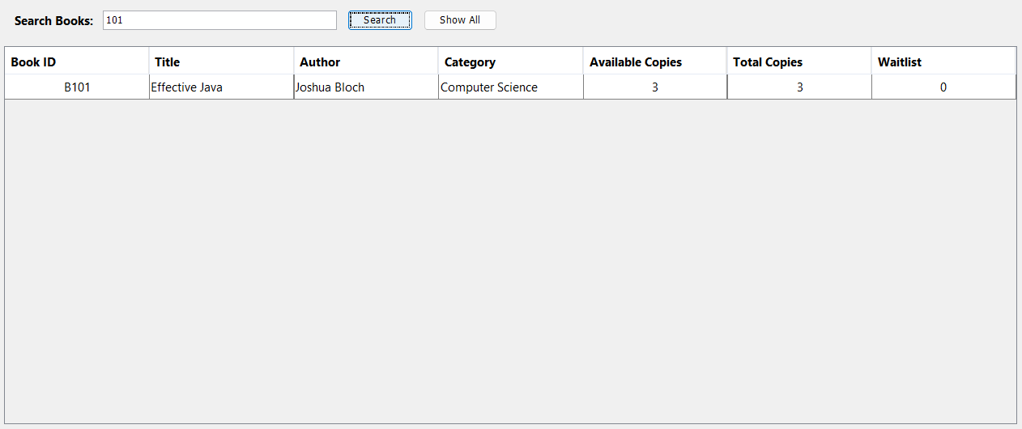

Figure 5: Issue Book
The Issue Book module allows the administrator to issue an available book to a registered member. The system verifies the book and member details, updates the inventory, records the transaction, and displays a confirmation message after successful issuance. 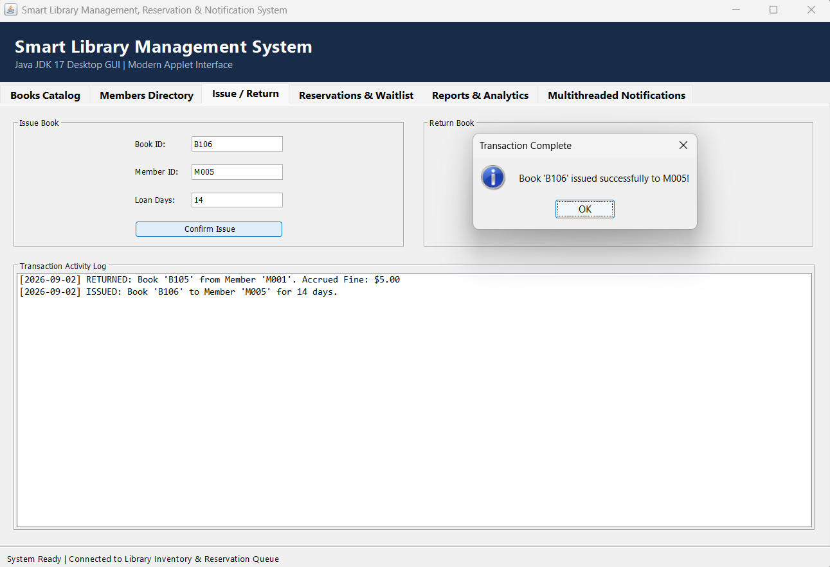
Figure 6: Return Book
The Return Book module processes the return of borrowed books. The application updates the inventory, checks whether the book was returned after the due date, calculates any applicable fine, and confirms the successful completion of the return process. 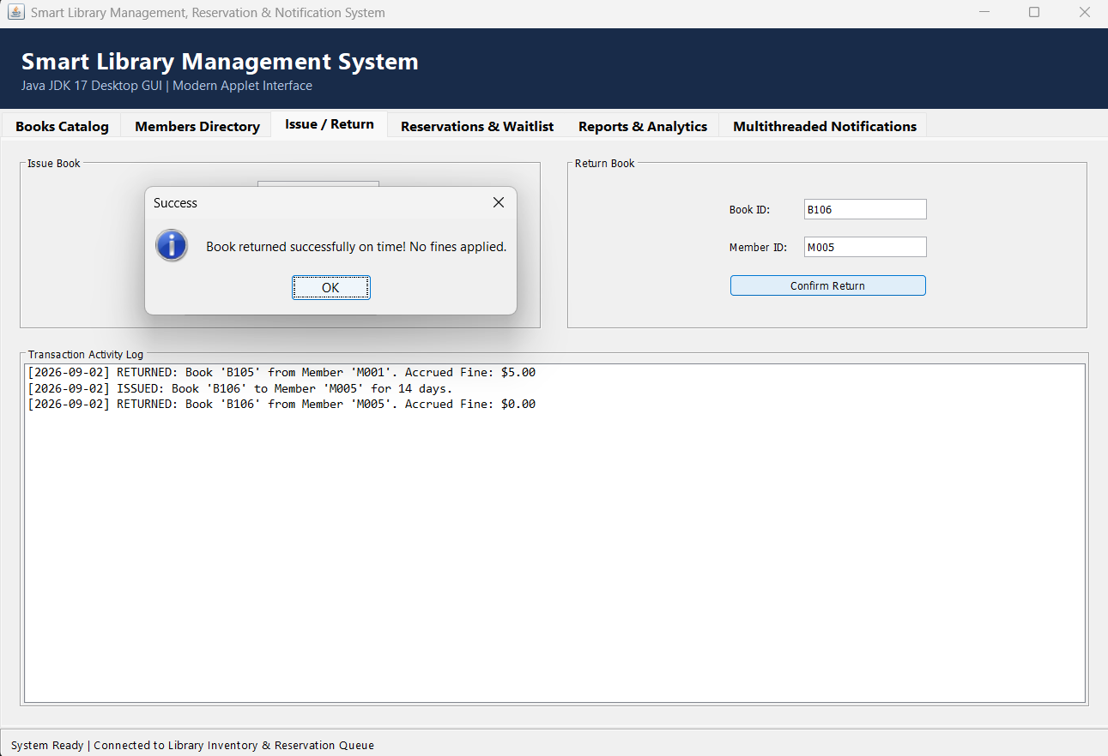
Figure 7: Reserve Book
The Reserve Book module allows members to reserve books that are currently unavailable. The reservation request is added to a waiting list, and the system confirms the reservation for future allocation when the book becomes available.
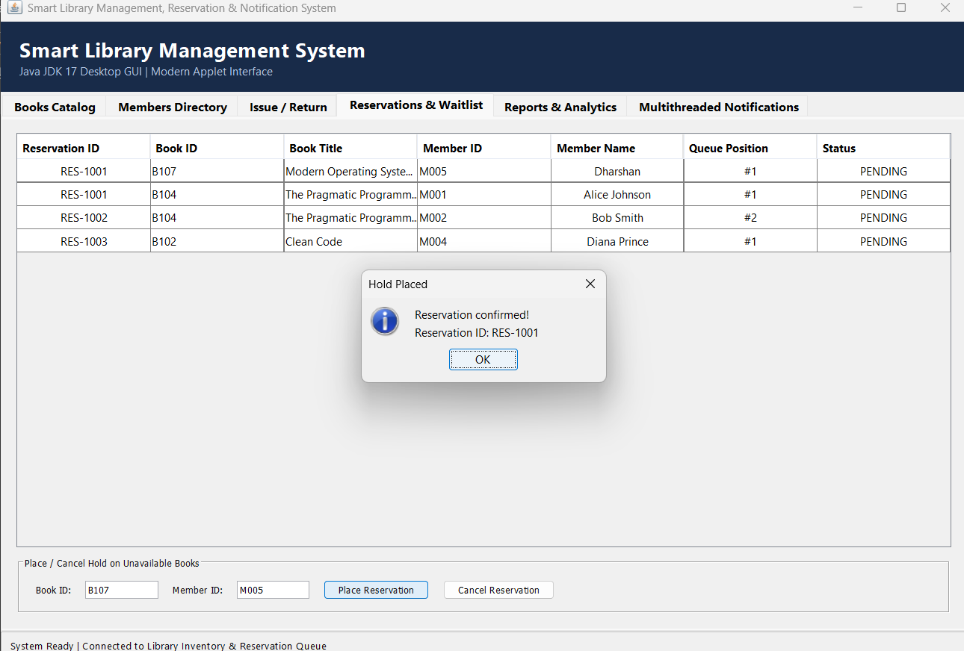
Figure 8: Cancel Reservation
The Cancel Reservation module enables members or the administrator to cancel an existing reservation. The system removes the reservation from the waiting list and updates the reservation records accordingly.
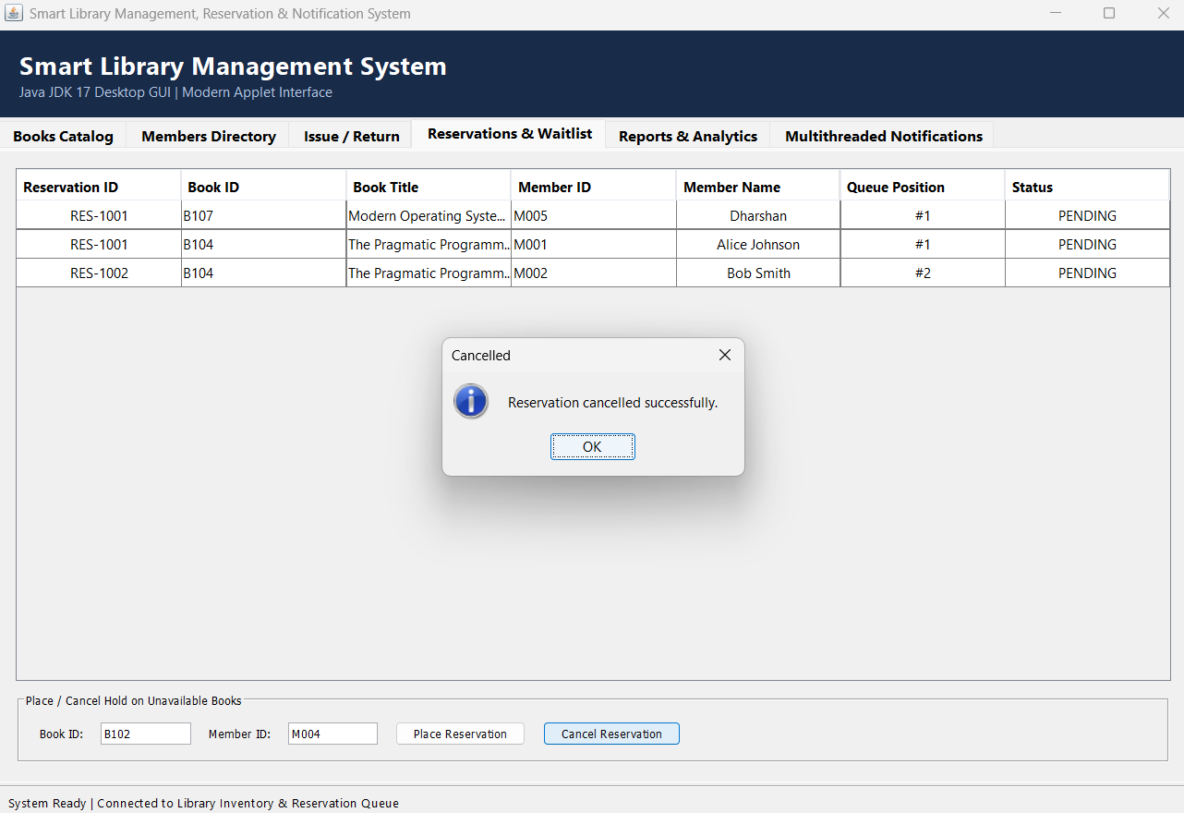
Figure 9: Display Books
The Display Books module shows the complete list of books available in the library. The displayed information includes Book ID, title, author, category, available copies, and current availability status, enabling efficient inventory management.
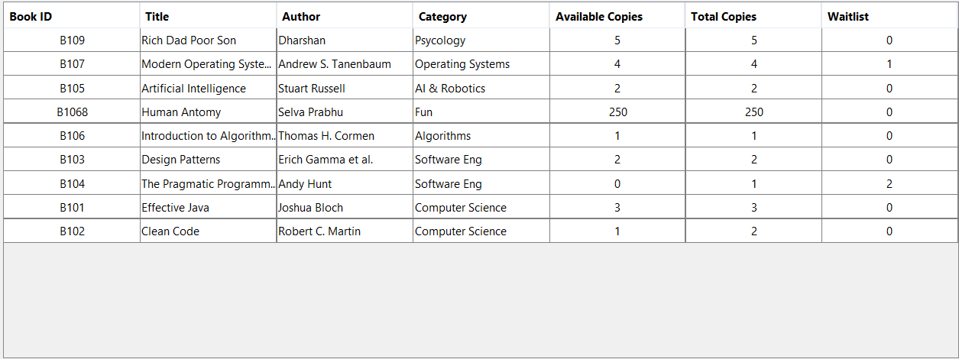
Figure 10: Display Members
The Display Members module lists all registered library members along with their Member ID, name, membership type, and other relevant information. This feature helps the administrator verify and manage member records efficiently.
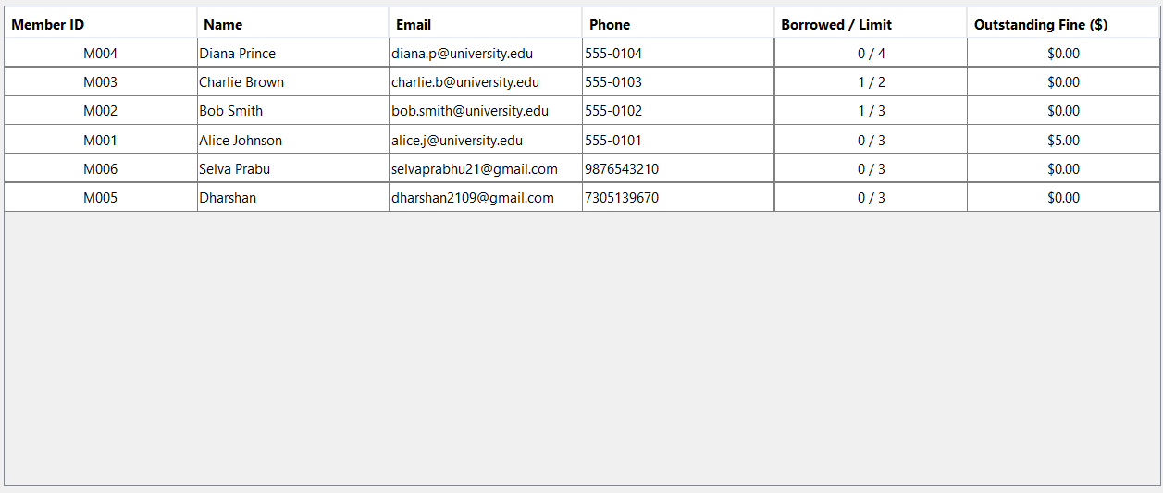

Figure 11: Generate Reports
The Generate Reports module provides a summary of library activities, including issued books, returned books, available inventory, reservations, and overdue fines. These reports assist in monitoring library operations and evaluating resource utilization.
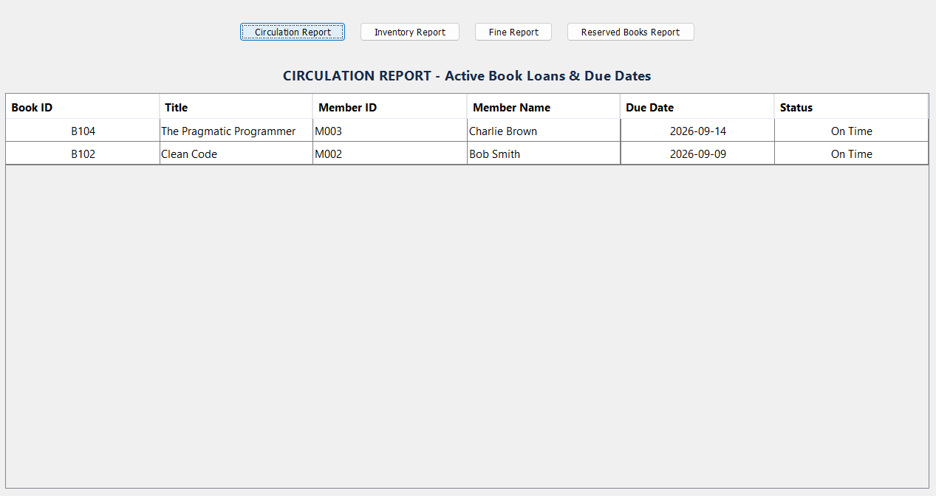
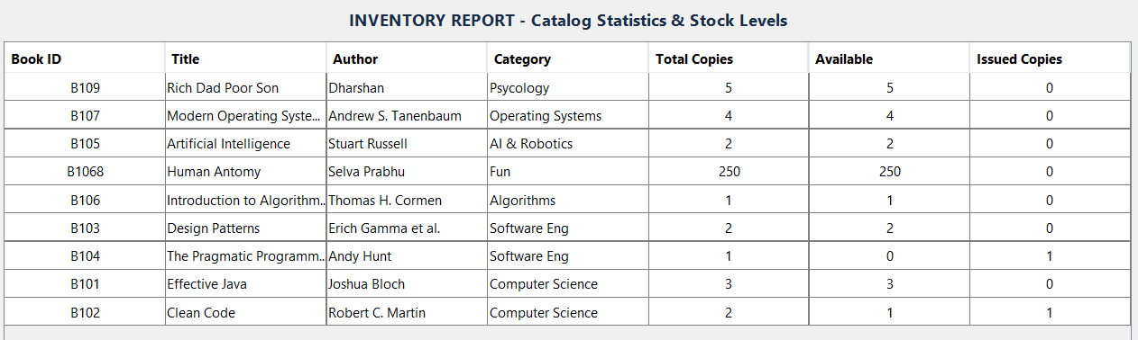
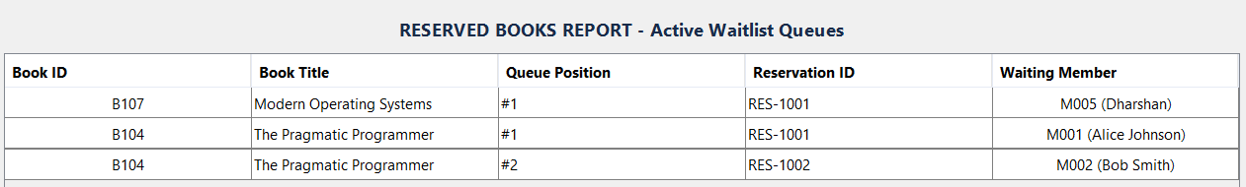

Figure 12: Send Notifications
The Send Notifications module automatically generates due-date reminders and overdue alerts for members. Notifications are displayed through the console, helping members return books on time and improving overall library management.
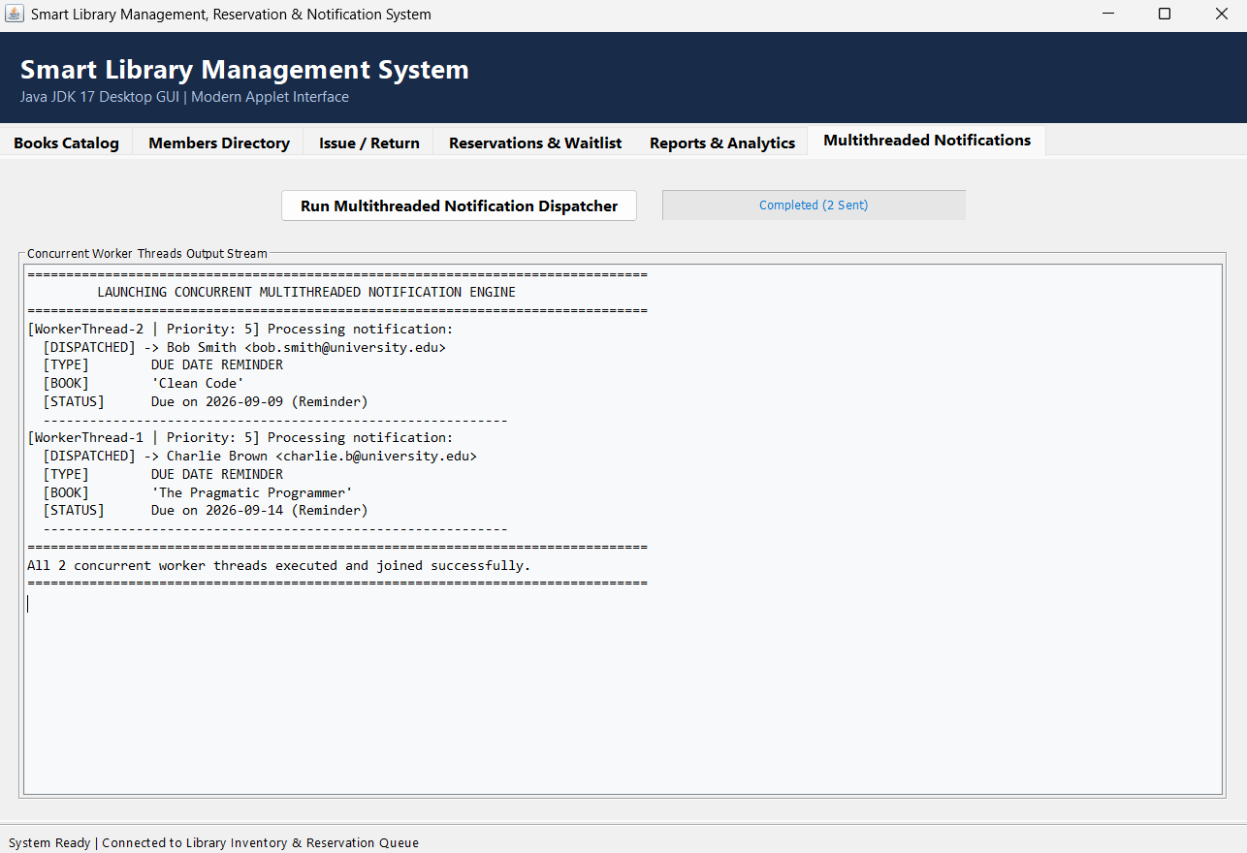
Figure 13: Exception Handling
The application validates user inputs before processing any operation. If an invalid Book ID, Member ID, duplicate reservation, or incorrect menu option is entered, the system displays an appropriate error message using Java exception handling mechanisms without terminating the application unexpectedly.
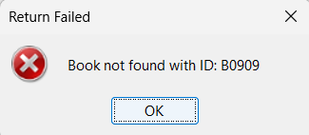

10. Results and Validation
Module | Result
Book Management | Successful
Member Management | Successful
Book Issue | Successful
Book Return | Successful
Reservation | Successful
Reports | Successful
Notifications | Successful
The application successfully performs all required operations. Testing confirmed that the implemented modules behave correctly, manage library records accurately, and generate the expected outputs, satisfying the assignment objectives.
11. Analysis, Comparison, Trade-offs and Justification
Advantages
- Fast execution
- Easy navigation
- Modular code
- Efficient searching
- Object-oriented design
- Supports concurrent notifications
Limitations
- GUI-based interface
- CSV files used as persistent database
- No database integration

Future Improvements
- Java Swing or JavaFX GUI
- MySQL database (future enhancement from current CSV storage)
- Email notifications
- Barcode scanning
- Online reservation portal
12. Broader Considerations / SDG Relevance
SDG 4 – Quality Education
Provides efficient access to library resources and supports learning.
SDG 9 – Industry, Innovation and Infrastructure
Uses modern software engineering concepts for digital library management.
SDG 16 – Peace, Justice and Strong Institutions
Maintains accurate records and transparent circulation management.
13. Conclusion
The Smart Library Management System successfully automates the daily operations of a library using Java. It demonstrates Object-Oriented Programming, Java Collections Framework, Exception Handling, and Multithreading while providing efficient book management, member registration, reservation handling, report generation, and notification services. The project satisfies the functional requirements of the assignment and provides a scalable foundation for future enhancements.

14. Individual Contribution of Group Members
Member | Contribution
Mohan Raj V D | Requirement analysis, project planning, GUI design, and documentation.
Monesh S | Developed the Book Management module (Add, Update, Delete, Search Books) and implemented CSV file handling for book records.
Selva Prabhu A K | Developed the Member Management module, Book Issue & Return module, and integrated CSV database operations for member and transaction records.
Ganesh | Implemented the Reservation, Notification, and Report Generation modules. Assisted with exception handling and GUI event handling.
Dharshan A N | Performed testing, debugging, validation, prepared screenshots, final report documentation, and coordinated project integration using Antigravity AI assistance.

15. References
- Oracle Java SE Documentation
- Java JDK 17 Documentation
- Herbert Schildt, Java: The Complete Reference
- Joshua Bloch, Effective Java
- IntelliJ IDEA Documentation
- Antigravity AI Documentation

16. One-Page Individual Reflection
Individual Reflection - A K Selva Prabhu(192421224)
Working on this project provided me with valuable experience in software testing, documentation, and application integration. My responsibilities included testing different modules, validating application outputs, preparing screenshots, and assisting in report preparation. Through this work, I understood the importance of software quality assurance and proper documentation in software engineering projects. I also gained practical knowledge of GUI testing, CSV file validation, and exception handling while verifying the application's functionality. Antigravity AI assisted in organizing the project and generating portions of the code, but every feature was reviewed, modified, and tested before final integration. This project improved my analytical thinking, debugging ability, and teamwork skills. I learned how multiple software modules can be integrated into a single application while maintaining consistency and reliability. If more time were available, I would improve the application's user interface, introduce advanced reporting features, and replace CSV storage with a relational database. Overall, this assignment enhanced my understanding of Java application development and prepared me for future software engineering projects.

